**Internet-of-Things (IoT) Weather Data Station**

**Project overview:**   
This project involved the assembly and configuration of a weather station electronics kit to retrieve and display real time weather data for a specific location (Charleston, SC). I have never used a soldering iron before and was curious if it was something I could do. I found this kit at The Science Hut ([Weather Station Electronics kit](https://thesciencehut.com/products/wifi-weather-station-electronics-kit)).

**Solo Contributer:**  
As the sole individual of this project my responsibilities included hardware assembly, software configuration, system deployment, and debugging.

**The Process:**  
The goal was to get a pre-built weather station kit to work. The core task was to assemble the hardware components and to configure the existing code. This required me to understand how the system was designed to operate and provide the correct parameters.

**Action and Technical Breakdown:**  
Physical Assembly- I began by assembling the hardware kit, which involved connecting the microcontroller to an LCD screen and a Wi-Fi module. I carefully followed the wiring diagrams provided to ensure all connections were secure.

API Key Configuration- I researched and signed up for a weather data API to get an authentication key.  
  
Wi-Fi Connectivity- I identified the section of code that held the network settings. I input my home network's SSID and password, which was a critical step for enabling the device to connect to the internet and access the weather API.  
  
**Results:**   
Functional System: The project resulted in a fully operational IoT weather station that successfully retrieves and displays real-time weather information from an external API.

**Demonstrated Skills: This project is a tangible example of my proficiency in:**

System Integration: Connecting hardware and software components to form a functional system.

API Utilization: Understanding and providing the correct authentication key for an external service.

Configuration Management: Adapting pre-written software to meet specific requirements.

Step 1: Remove all components from packaging and organize.

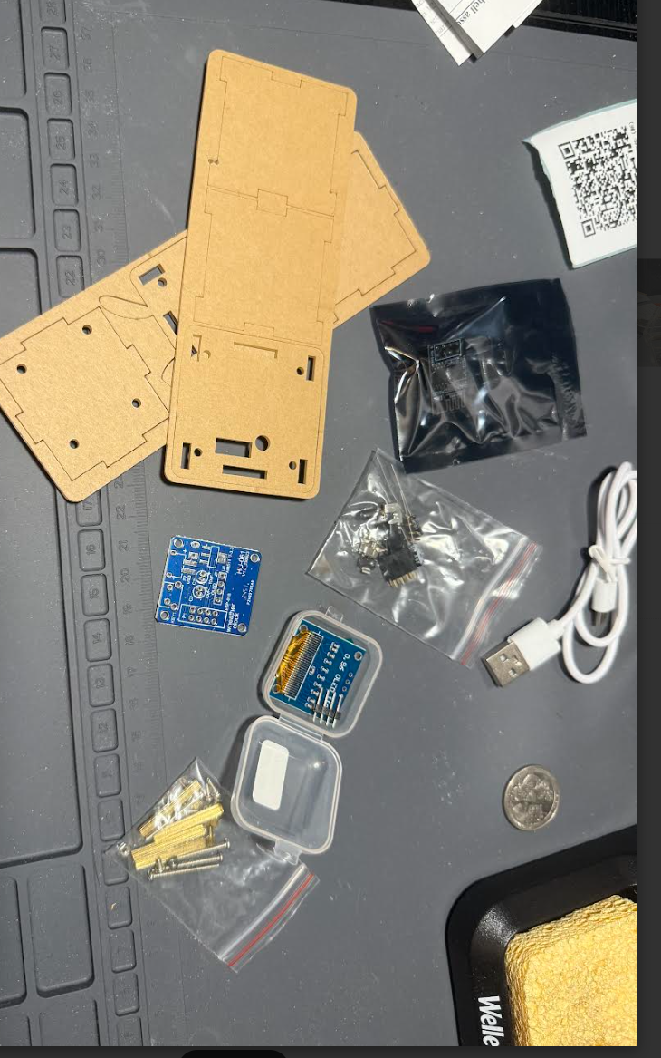 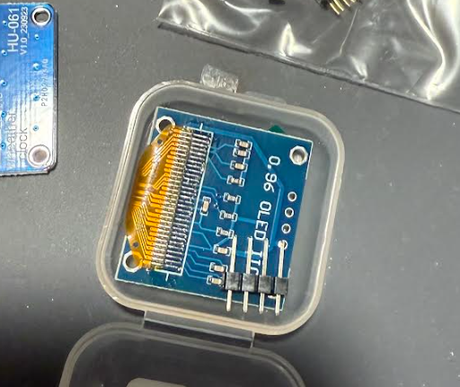  
  
Step 2: Begin assembly by soldering components to chip board using lead-free solder wire.   
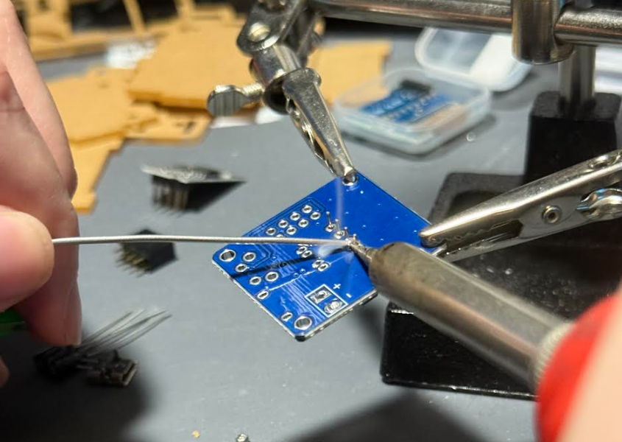 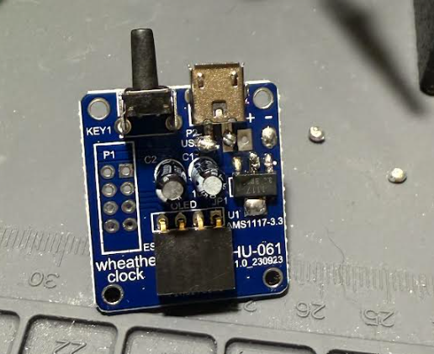 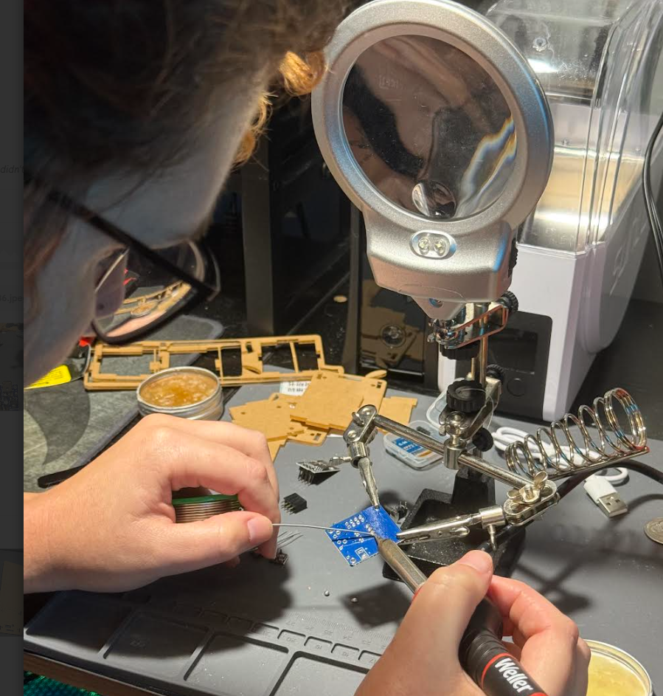

Step 3: Once all components and capacitors are soldered, attach OLED screen.  
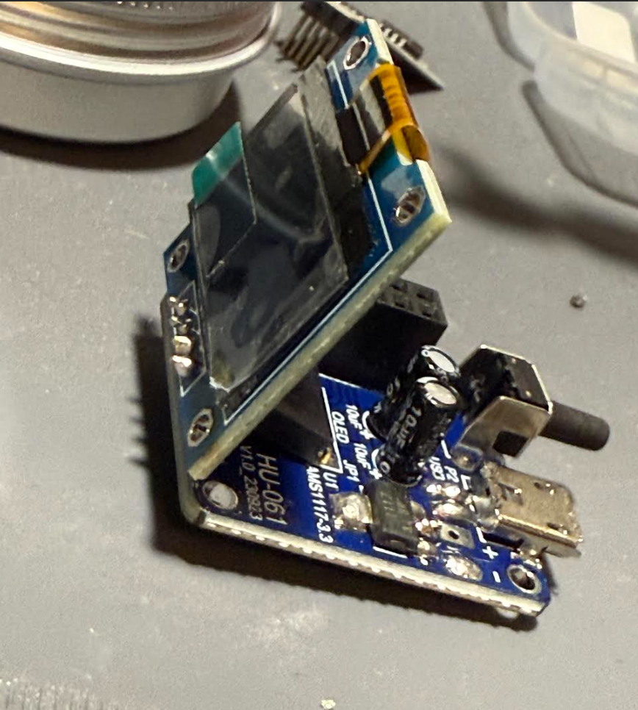 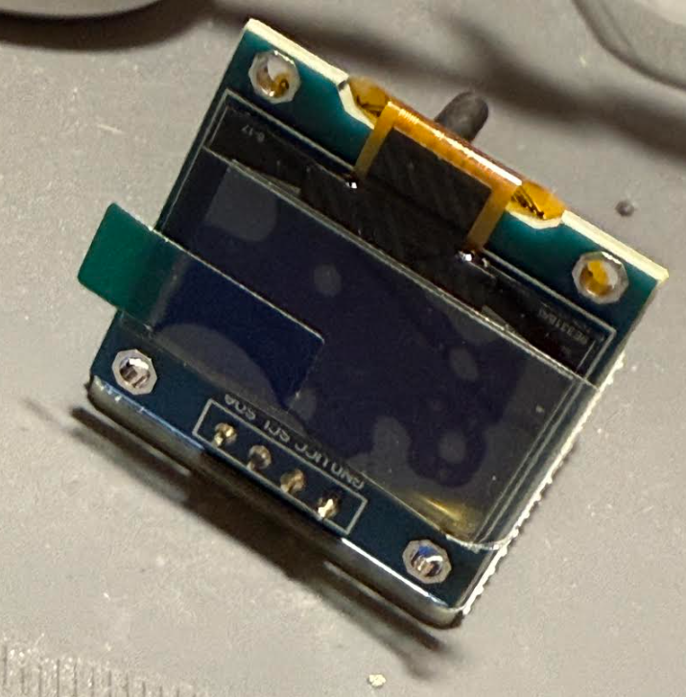  
Step 4: Connect the Wi-Fi module to the double row socket.   
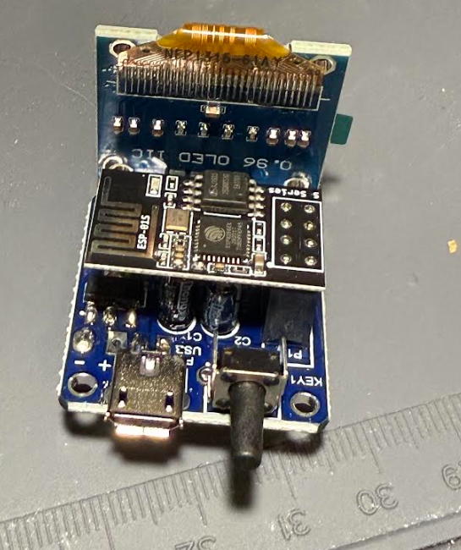

Step 5: Attach the case.  
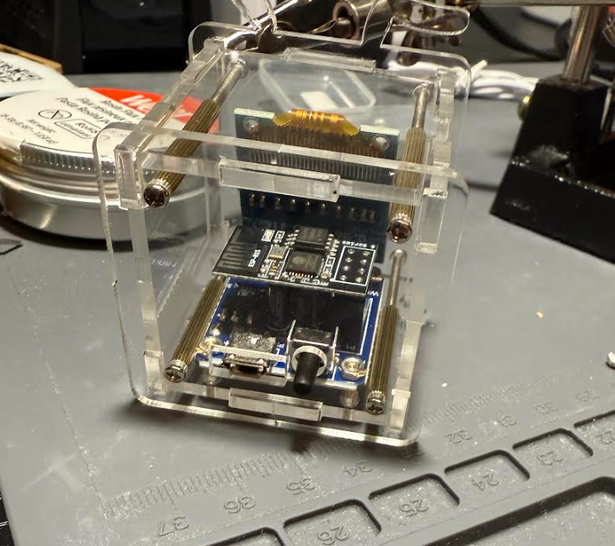 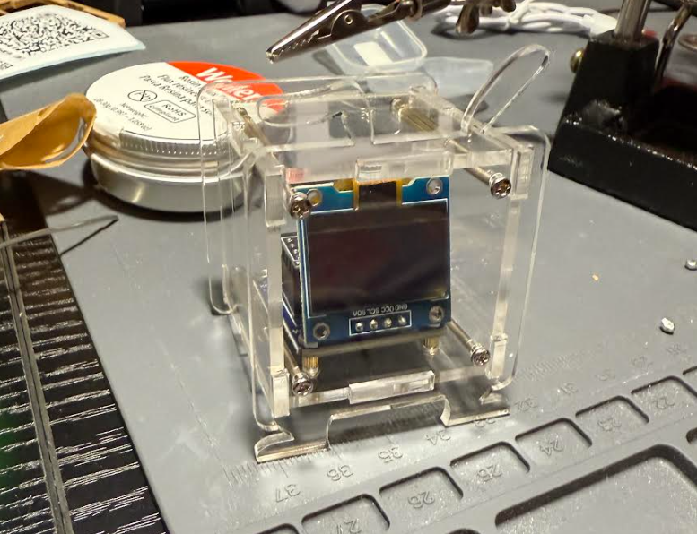

Step 6: Setup and Configuration  
 1. Obtain the city ID for the location you want the weather displayed for. In this example I used Charleston SC. The city ID for that location is CB8B.  
 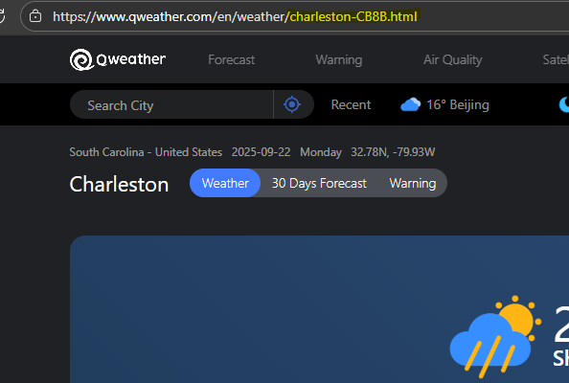  
 2. Plug in the weather station and connect to Wi-Fi. Weather station will connect to your phone via Wi-Fi, and have you input the weather key (comes with the device) for the device and the city ID that that was obtained above. Once those credentials are saved you can enter your WI-FI information into the device.  
 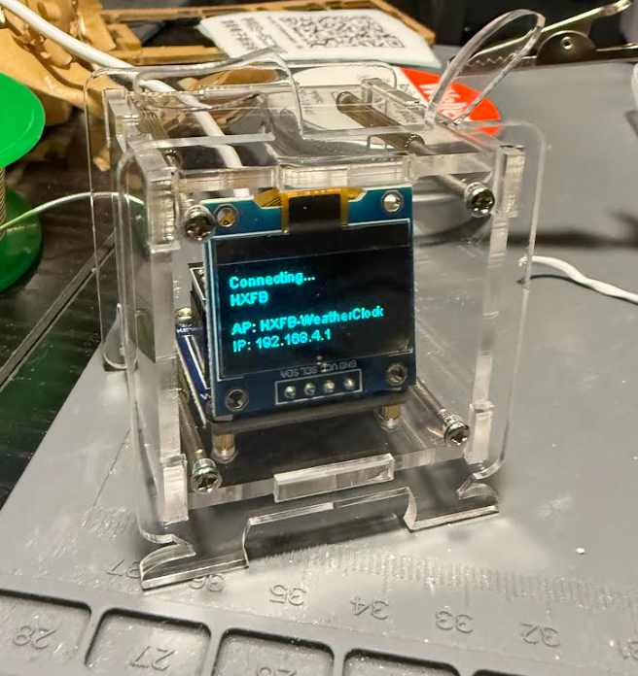 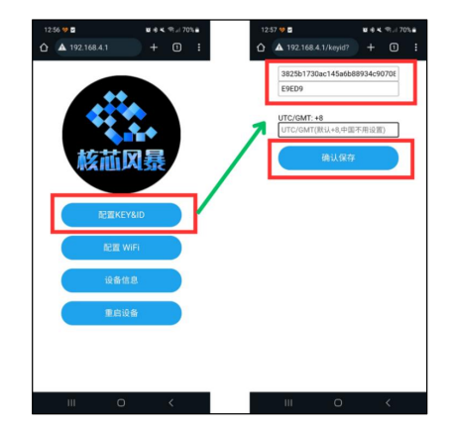

Step 7: Once the device is complete you can see various weather conditions about the location you chose the code for. (You will notice in the following photos that the bottom right corner of the display screen has a blemish. This was my first time using soldering equipment and I held the soldering pen too close to the display screen.)  
